**Convert RGB image to YCbCr image**

1. Y component

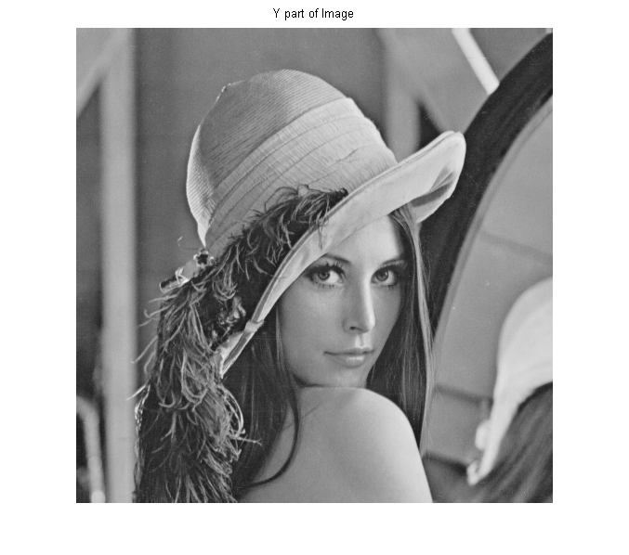

1. Cb component

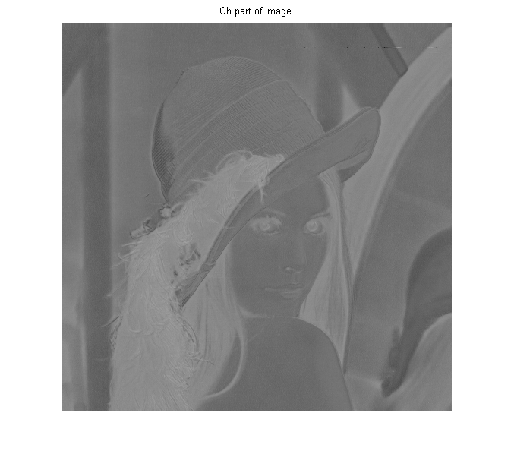

1. Cr component
2. 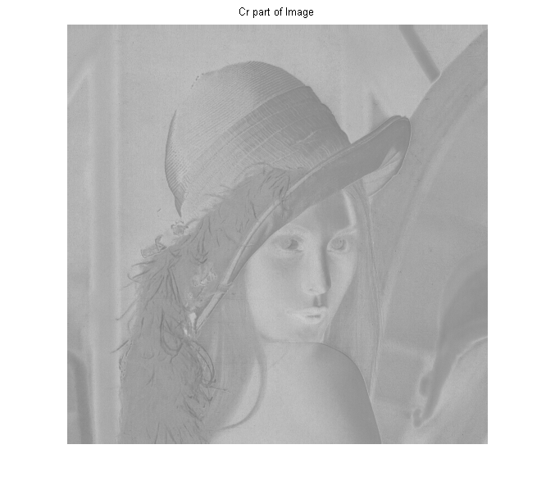
3. Code (Matlab)

I = imread('D:\Document\Master\Image Processing\lena.bmp');

imshow(I); title('Original Image');

X = reshape(double(I),size(I));

T = X;

[m,n,p]=size(I);

T(:,:,1)=0.299*X(:,:,1) + 0.587*X(:,:,2) + 0.114*X(:,:,3);

T(:,:,2)=0.564*(X(:,:,3) - T(:,:,1)) + 128;

T(:,:,3)=0.713*(X(:,:,1) - T(:,:,1)) + 128;

T = reshape(uint8(T),size(I));

figure(2), imshow(T); title('YCbCr Image');

Y = T(:,:,1);

figure(3), imshow(Y); title('Y part of Image');

CB = T(:,:,2);

figure(4), imshow(CB); title('Cb part of Image');

CR = T(:,:,3);

figure(5), imshow(CR); title('Cr part of Image');